6th November 2013

To all FIA Member Clubs

Dear President

2013 Statutes Amendments – A Chance to Overcome the FIA’s Democratic Deficit
This year’s presidential election has the highest ever candidate eligibility requirement in the history of the FIA. Although the election list has been reduced in size since 2009 this has been offset by a new provision to include support nominations by clubs. As a result a candidate now has to submit a list and support nominations totalling 37 compared with 24 in last election. This is excessive and increases the democratic deficit in the FIA’s election system.
Fortunately some clubs have now tabled statute amendments to significantly reduce the size of the list and nomination requirement to seven. This will be the third time since 2007 that clubs have tried to make the FIA’s presidential election system in the words of the AAA, the ANWB and the ADAC “a more democratic and open election procedure”. The new proposals have the same goal and would reduce the Presidential list to the four most senior leadership positions supported by just three club nominations from each membership category. Copies of the proposed statue amendments are available on my website at:
I have also prepared a briefing paper which compares the eligibility requirements of the FIA election system used in recent elections and the changes to them proposed in 2007, 2008 and now again in 2013. Regardless of your clubs voting intentions in the 2013 election I would respectfully ask you to consider carefully the briefing paper and the analysis it contains about the weaknesses of the current FIA election system.
It is likely that the FIA leadership will try to block the new statutes reforms. They will propose referring them to the Statutes Review Commission and encourage the World Councils to oppose a vote at the General Assembly. Whilst the World Councils should be able to make recommendations on statute changes tabled by clubs, in my opinion they should not be allowed to block them. To do so would abrogate the sovereign authority of the General Assembly.
Rather than wait for more internal review the FIA membership now has the opportunity to vote for change. If approved the 2013 reform proposals will reinvigorate the FIA’s democratic system making it less complex and time consuming but crucially also more accountable and fair.
I strongly believe that governance reform rather than who will be the next FIA President is the major issue of the 2013 election. I would, therefore, strongly encourage your club to vote in favour of the statute changes that will now be on the agenda of the 2013 General Assembly.

With best wishes

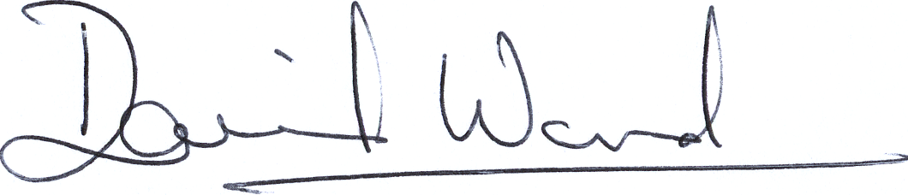

David Ward
Candidate in the 2013 FIA Presidential Election
www.wardandteam.2013

